**Abstract**

# **Video Text Detection Using Stroke Width Transform**

|  |  |
| --- | --- |
| Erol Özkan  Department of Computer Engineering, Hacettepe University  erolozkan@outlook.com | Rahem Abri  Department of Computer Engineering, Hacettepe University  rahem_abri@hotmail.com |

*Reading text from photographs and videos is a challenging problem that has received a significant amount of attention in recent years. In this paper, we propose an approach for single image text detection and we extend this approach to videos. For text detection task, we transform our image into its stroke width representation to extract the basic letter candidates. Then we filter out these candidates using some geometric reasoning methods. For video text detection task, we extract the text locations via same method in each frame. Then, we analyze the motion patterns of the text components in frames to localize video texts. We evaluate our system on ICDAR challenge datasets. Our proposed single frame image text detector as the base of our video text detection approach shows promising results.*

# Introduction

Human beings find the identification of text in an image almost effortless, and largely involuntarily. As a result, in our daily lives, much important information is conveyed to us in this form, including navigation instructions and warnings. Simulating such an ability for machine vision system has been an active topic in the vision and many methods has been proposed to understand the text on scanned documents and photographs.

However, there is a considerable gap between detecting and understanding text in scanned documents and detecting and understanding text in the natural images. Understanding text in scanned documents is fairly easy, because in scanned documents, the characters are typically monotone on fixed backgrounds and they have the same font, same color, same size and same orientation everywhere. However, in natural scenes, text detection is made difficult by high variation in character color, font, size, and orientation. That’s why detection and understanding the text in natural photographs involves localizing the text as well as removing the variation factors, such as varying text orientation, font, color and lighting.

In this paper, we present an approach based on the Stroke Width Transformation that provides improved text detection in natural images. Then, we extend this approach to video text detection problem domain. In each frame, we transform our image into SWT representation and apply several filters to remove non-text components in the frame. After that, we try to combine detected text regions in each frame for better detection performance and fewer number of false positives. We evaluate our system based on the ICDAR challenge which is the most widely used benchmark for text detection task.

The remainder of this paper is structured as follows. Next section briefly addresses ICDAR challenge. Section 3 describes the related work in scene text recognition. Section 4 describes in detail our approach for single image text detection. Section 5 describes our approach for video text detection. Evaluation method, experimental results and concluding remarks are presented in Section 6, Section 7 and Section 8 respectively.

# ICDAR Challenge

The International Conference on Document Analysis and Recognition (ICDAR) is an international academic conference which is about character, symbol recognition of printed/handwritten documents and graphics. It has been held five times, in 2003, 2005, 2011, 2013 and 2015. Four datasets have been published including; digital born, focused scene, text in videos, incidental scene texts respectively. And also, there have been three different tasks that need to be performed on the test images, including text localization, text segmentation and text recognition.

In this paper, we perform our experiments on the ICDAR challenge and our focus is on text detection and text segmentation tasks. We experiment with the second and third datasets which are “focused scene text” and “text in videos” datasets respectively. We evaluate our single image text detection approach on “focused scene text” dataset and video text detection approach on “text in videos” dataset.

# Related Word

Text recognition has generated significant interest from many branches of research. Although, it is now possible to achieve extremely high performance on some tasks such as scanned document character recognition, the task of detecting and labeling characters in complex scenes still remains an active research topic.

For scene text detection, solutions have ranged from simple off-the-shelf classifiers trained on hand-coded features to multi-stage pipelines combining many different algorithms. Existing approaches generally fall into one of three categories, namely, texture-based approaches, region-based approaches, and hybrid approaches.

**Texture-based** **approaches;** extract distinct texture properties from sliding windows, and use a classifier such as AdaBoost to detect individual instances. Some widely used features include Histograms of Gradients (HOGs), Local Binary Patterns (LBP), Gabor filters and wavelets. Foreground regions on various scales are then merged to generate final text regions which is something profoundly unsatisfying about texture-based approaches. Firstly, the brute force nature of window classification is not particularly appealing. Its computational complexity is proportional to the number of scales. Secondly, an extra post processing step, i.e. text extraction, is needed before text recognition.

**Region-based approaches;** extract potential characters through edge detection, color clustering or Maximally Stable Extremal Region (MSER) detection. After that, low level features based on geometric and shape constraints are used to reject non-characters. As a final step, remaining regions are clustered into lines through measuring the similarities between them. A typical example of region-based approaches was proposed by Epshtein et al. [34], where a local image operator, called Stroke Width Transform (SWT), assign each pixel with the most likely stroke width value, followed by a series of rules in order to remove non-characters. All region-based approaches, although not particularly computationally demanding, involve many parameters that need to be tuned manually.

# Single Image Text Detection



Figure 1 : Overview of Our System

Our text detection approach starts with preprocessing phase where the image smoothed and enhanced to our needs before we transform our image into its stroke width representation. After extracting the basic letter candidates with stroke width transformation, we try to filter some non-text components by grouping similar pixels together into bigger components that are likely to be characters. Then, we try to define boundaries wrapping this components and fit a rectangle on them. Finally, we evaluate our detection score based on ground truth files that is obtained from ICDAR challenge datasets. Our system overview is shown in Figure 1.

## Preprocessing

In preprocessing phase; firstly, we convert our image into gray scale. After that, we smooth our image by using a Gaussian filter and apply histogram equalization. This operation slightly increases our scores by making it easier to identify text locations in our image. Furthermore it reduces false positive rate. Figure 2 shows our input image and Figure 2 shows our image after preprocessing phase.

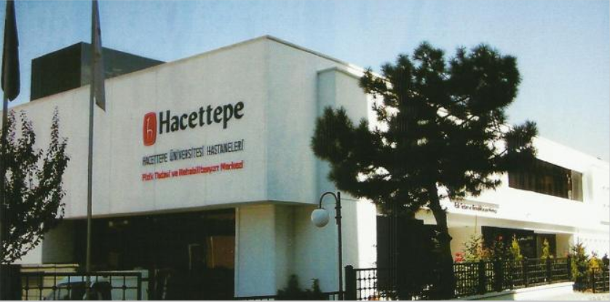

Figure 2 : Input Image

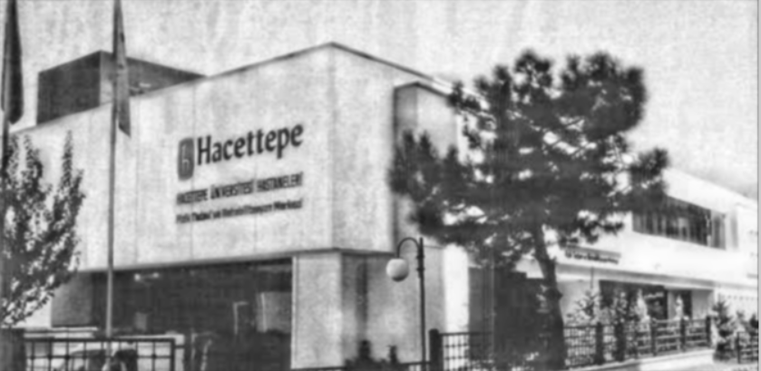

Figure 3 : Image after Preprocessing

## Stroke Width Transform

The main idea in stroke width transformation is that its ability to separate text from other high-frequency content contained in images. In a stroke width transformation, each pixel value is roughly the width of the stroke that contains the pixel. A stroke is defined as a part of the image that forms a band of constant width. In the first step, we find the edges of the input image by using Canny Edge Detector. Then, for each gradient direction dp of each edge pixel p is determined. A ray starting from p with the direction of dp is considered and followed until it meets another edge pixel q. If the gradient direction dq at edge pixel q is approximately opposite to dp, the distance value of p and q is assigned to all the pixels that lie on the ray. Figure 4 shows stroke width transformation method. Figure 5 shows our SWT transformed image.

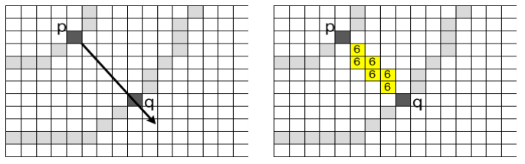

Figure 4 : Finding the gradient value of edge pixel p and shooting a ray in its direction and finding an edge pixel q with opposite gradient direction on the ray (left). Assigning the stroke width value to each pixel that lies on the ray (right)

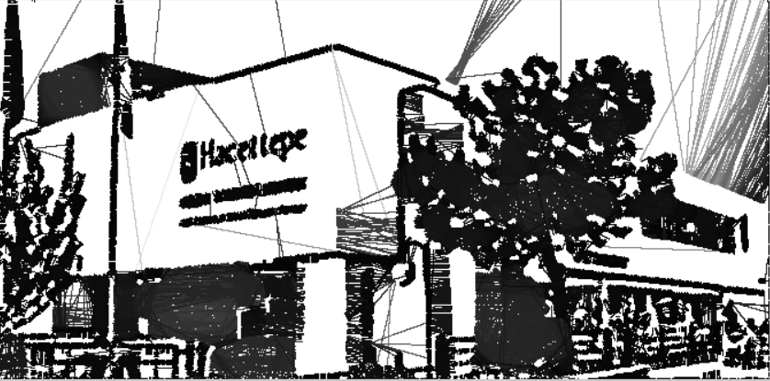

Figure 5 : Stroke Width Transformation Result

## Filtering Non-Text Components

After converting our image into its stroke width representation, we perform a bottom-up integration of information, merging pixels of similar stroke width into connected components, which allows us to detect letters across a wide range of scales in the same image.

Applying connected component algorithm on the SWT values, we obtain a binary image where the foreground CCs are considered as letter candidates. Then, we perform a set of simple and flexible geometric checks on each CCs to filter out non-text objects. First of all, we reject very large and very small objects. Then, since most letters have aspect ratio being close to 1, we reject CCs with very large and very small aspect ratio. Lastly, we eliminate objects which contain a large number of holes, because CCs with many holes are unlikely to be letter candidates.

Figure 6 shows our image after first filtering. Gray pixels has been spotted as non-text components and they are going to be removed in this phase.

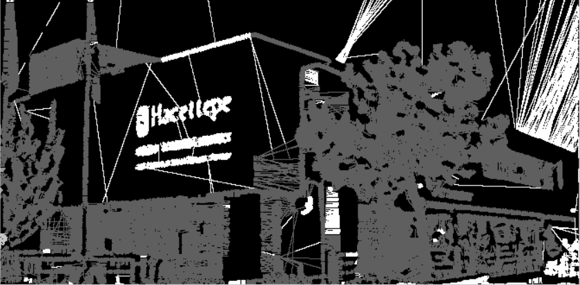

Figure 6 : Component Filtering Result

Figure 7 shows our image after final filtering. This figure clearly shows how effective SWT can be in finding text locations in images after removing non-text components.

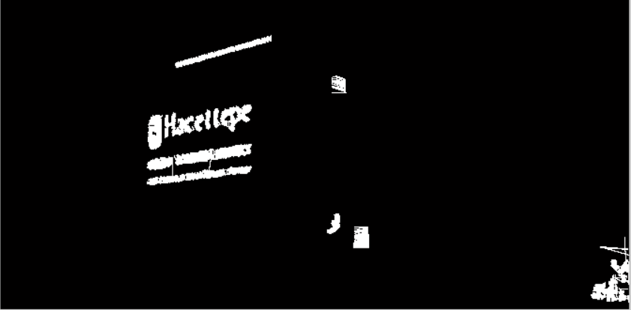

Figure 7 : Final Filtering Result

## Boundary Filling and Detection

After filtering non-text components, we try to define a boundary on remaining components using matlab’s “strel” function. We create disk-shaped structuring elements that contain the remaining components in our image. Figure 8 shows our image after boundary filling phase.



Figure 8 : Boundary Filling

Finally, we try to fit a rectangle on this boundary to represent text regions detected by our system. Figure 9 shows the detected text regions in our input image.

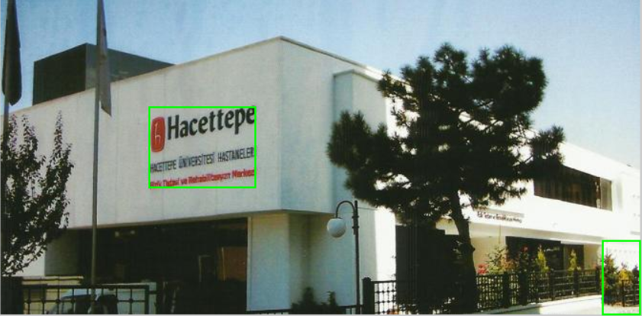

Figure 9 : Detected Text Regions

# Video Text Detection

The proposed video text detection performs a basic motion analysis via voting between frames in order to detect the actual video texts components and distinguish them from the rest on the video.

Firstly we start with detecting the text regions. This step is exactly the same as the single image text localization technique explained previously, based on CCs that benefits from SWT. Figure 10 shows a video volume that contains defined boundaries on remaining components after removing non-text components. Figure 11 shows a video volume that shows detected text regions on this volume.

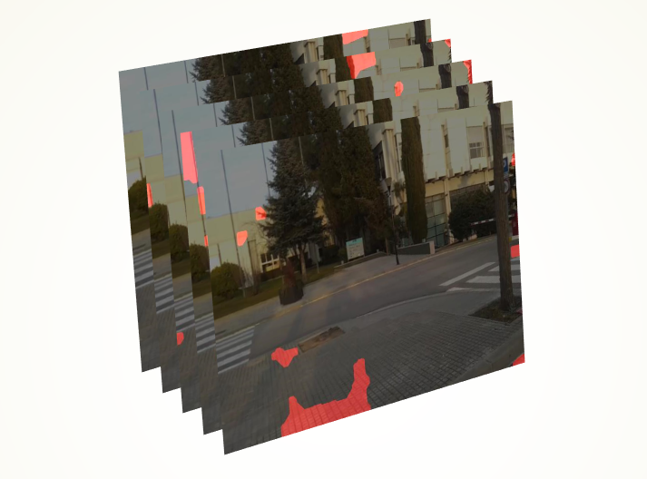

Figure 10 : A Video Volume That Shows Defined Text Boundaries

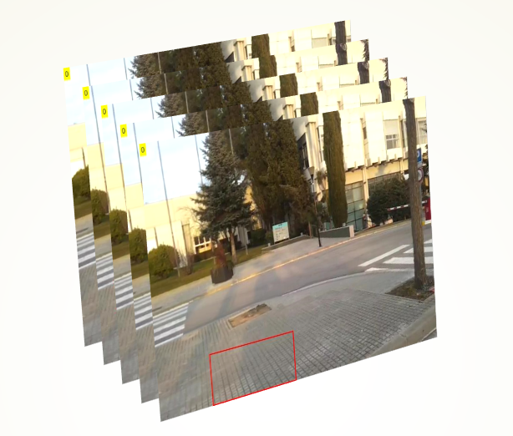

Figure 11 : A Video Volume That Shows Detected Text Regions

After defining text boundaries, we iterate our video by taking small video volumes that contains a video sequence of 1, 3, 5, 7 frames respectively. We make a voting on these defined boundaries. Then we make a reasoning to include that text region in the final video result by thresholding components based on their votes in each video volume. Figure 12-14 shows our voted components.

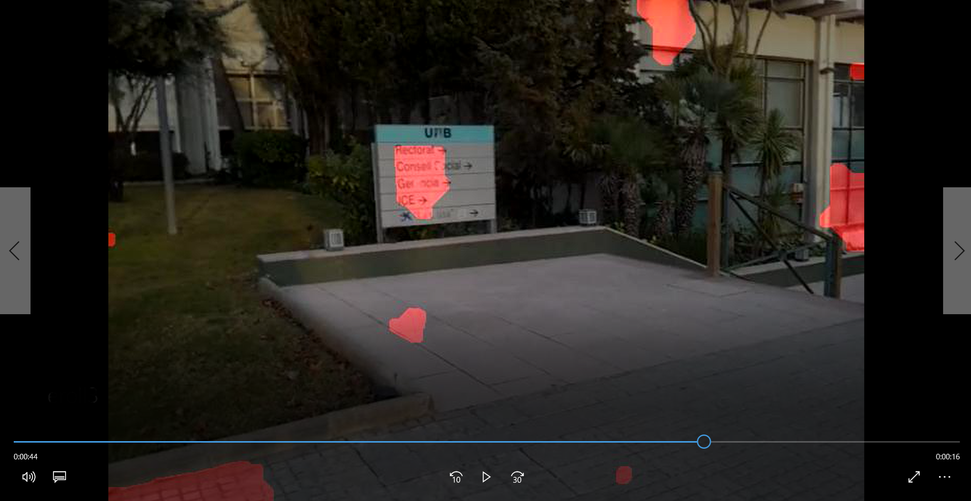

Figure 12 : Single Frame Components

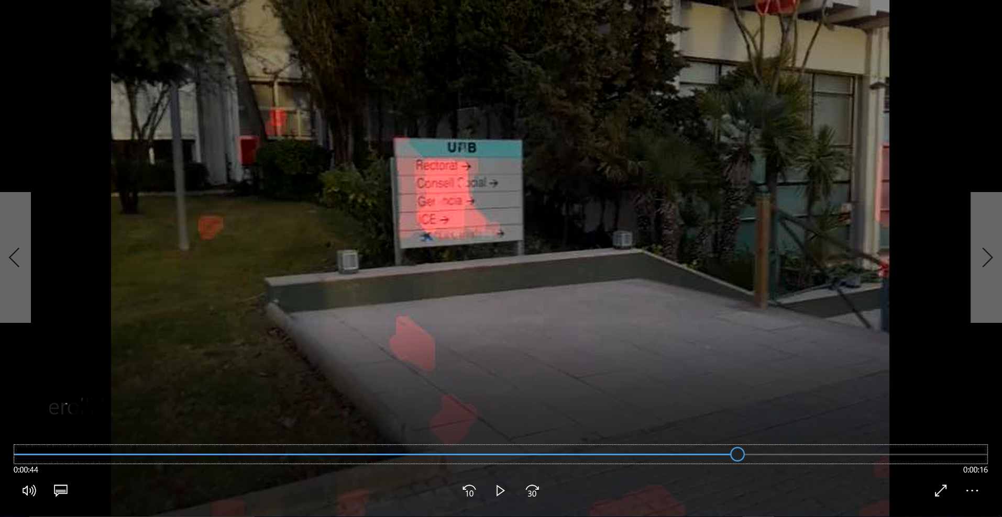

Figure 13 : Three Frame Voted Components

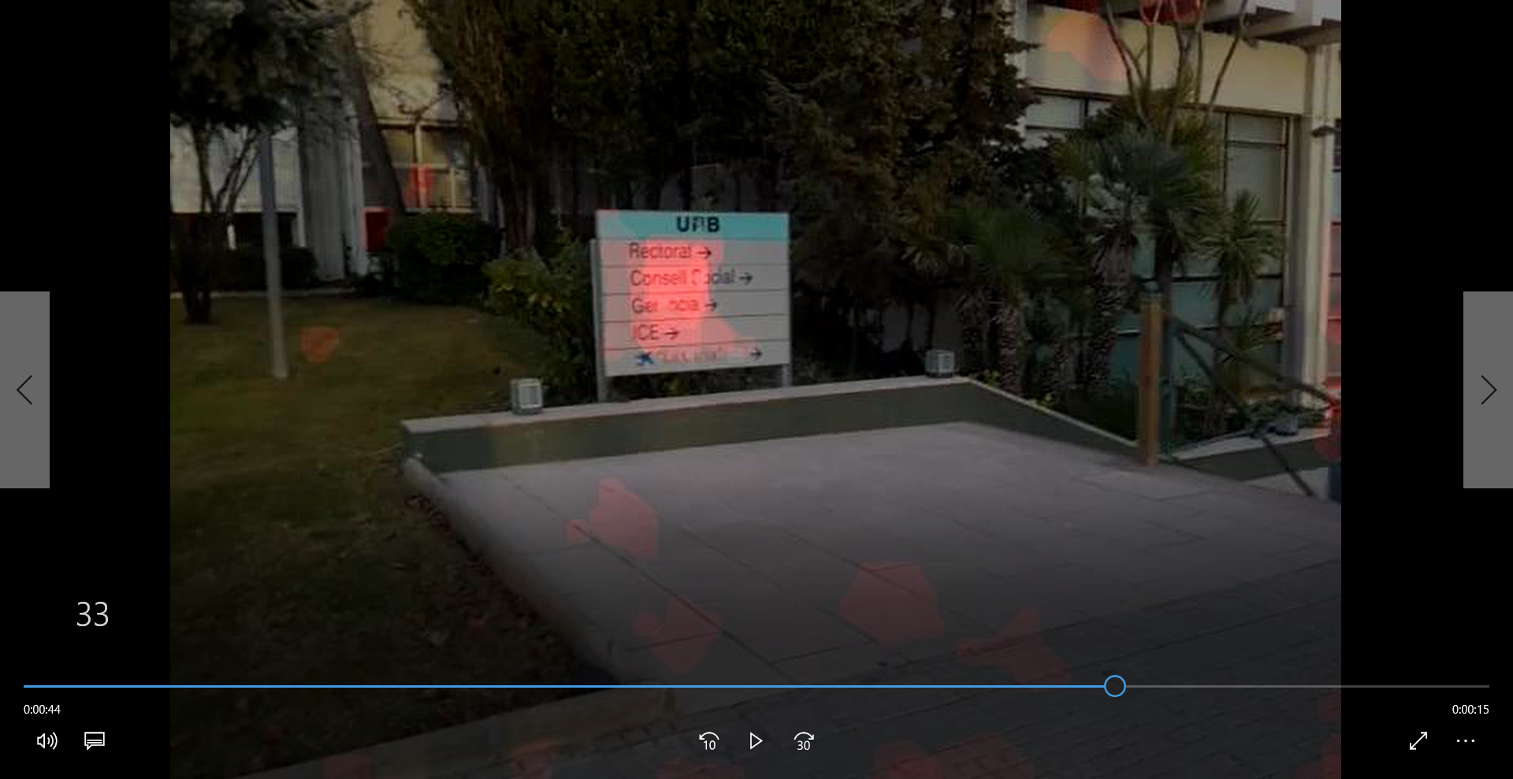

Figure 14 : Five Frame Voted Components

Figure 15 shows our detected regions using five frame voted components. Here, using voted components to detect text regions increases our consistency by decreasing false positives rate.

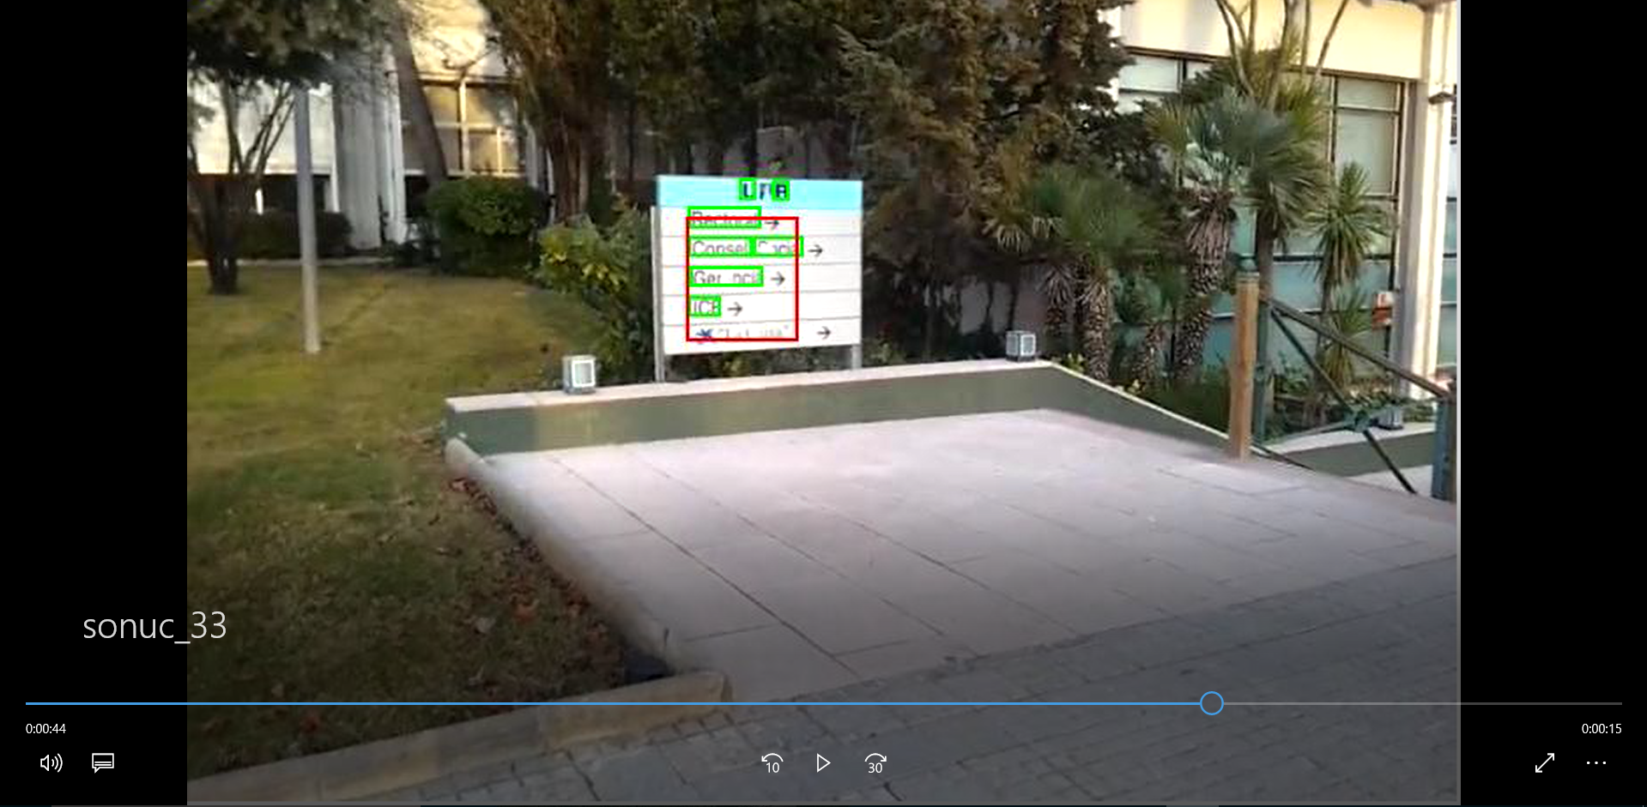

Figure 15 : Text Detection Result Using Five Frame Voted Components

# Evaluation

As mentioned before, an important contribution of our work is the single image text detection approach which is also used as the base of our video text detection approach. Therefore, in this subsection we start with analyzing our single image text detection evaluation strategy. Next, we analyze our video text detection evaluation strategy.

## Single Image Text Detection

The output of our system is a set of rectangles designating the bounding boxes detected by our system. This set is called estimate set. And a set of ground truth boxes provided in the ICDAR challenge dataset is called target set.

In our system, we calculate the match score between two rectangles dividing the area of intersection by the total area of two bounding boxes. This number has the value one for identical rectangles and zero for rectangles that have no intersection. When there are more than a rectangle in either estimate set or target set, we find the closest matches in sets. Some examples that shows our match metric are shown in Figure 12.

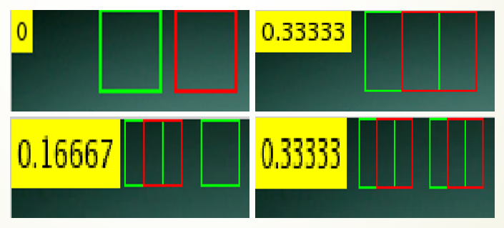

Figure 16 : Match Metric

In first image, since there is no intersection between two rectangles, match score is zero. In second image, the overlap between two rectangles is half for each. We divide the area of overlap by the total area, so we get a value of 0.3333. In third image, there is a rectangle in estimate set and there are two rectangles in the target set. The first pair has a match score 0.3333 and second pair has a match score 0. The mean match score is 0.16667. In fourth image, there are two rectangles in estimate set and there are two rectangles in the target set. The first pair has a match score 0.3333 and second pair has a match score 0.3333. The mean match score is 0.3333.

Figure 13 shows our text detection evaluation strategy on an example image. Red rectangles indicate estimate set and green rectangles indicate target set. Mean match score between all of these rectangles is shown at upper-left portion of the image.



Figure 17 : Evaluation of an Example Image

## Video Text Detection

We evaluate our video text detection results to find out the effectiveness of our approach in videos. We perform the same performance analysis on our video. Instead of evaluating single image dataset, we consider time variable in our video sequence and we calculate match score for every frame in our video. Finally, we take the mean of match scores in frames.

# Experimental Results

## Single Image Text Detection

We evaluated our proposed single image text detection approach on the ICDAR “focused scene text” dataset. The dataset contains 251 color images of various sizes ranging from 307 × 93 to 1280 × 960. Along with the images, the dataset provides ground-truth locations of the texts that exist in the images, called targets. In Figure 14 some sample images from this ICDAR datasets are presented.



Figure 18 : Some Example Images from ICDAR Dataset

Figure 15 shows text detection results of our approach on these images.

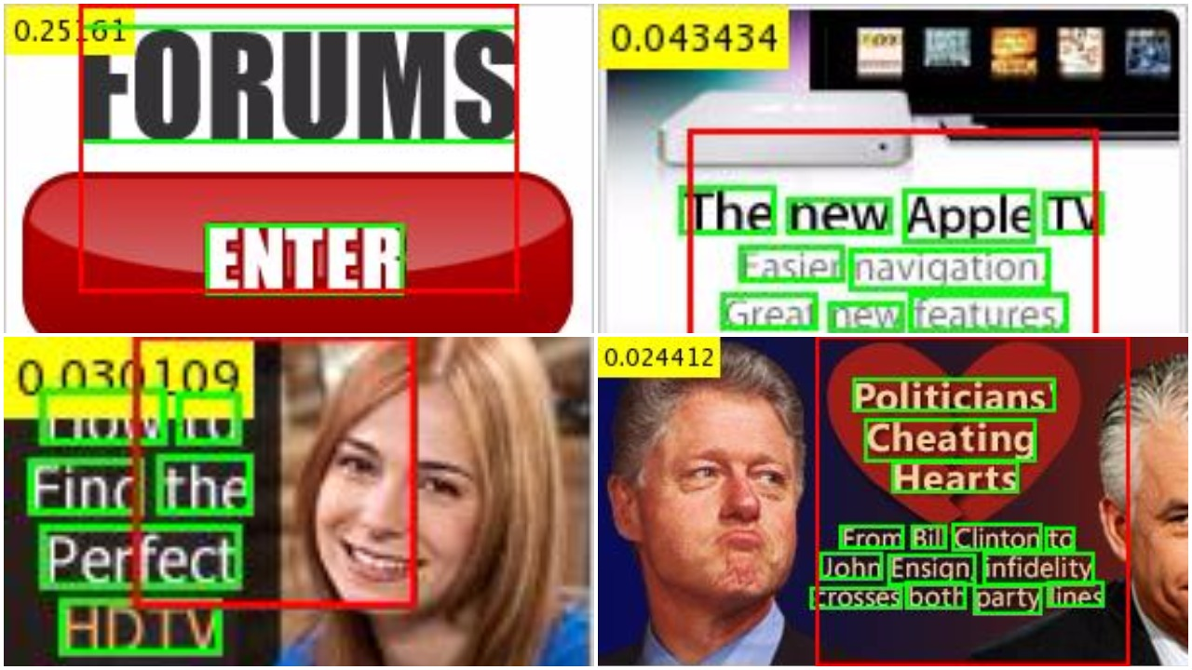

Table I presents the match score for some example images in ICDAR “focused scene text” dataset.

Table 1 : Detection Results for Some Images

|  |  |  |
| --- | --- | --- |
|  | **Light Text On Dark Background** | **Dark Text On Light Background** |
| **Image 1** | 0.0027 | 0.0642 |
| **Image 2** | 0.0563 | 0 |
| **Image 3** | 0 | 0 |
| **Image 4** | 0 | 0.0244 |
| **Image 5** | 0 | 0.0301 |
| **Image 6** | 0.0434 | 0 |
| **Image 7** | 0 | 0 |
| **Image 8** | 0.137 | 0 |
| **Image 9** | 0.0271 | 0 |
| **Image 10** | 0.2516 | 0.196 |

## Video Text Detection

We evaluated our proposed video text detection approach on one of the videos in ICDAR “text in videos” dataset. This video sequences have 602 frames in total. For each frame we have target texts locations marked as ground-truth text locations. After performing the video text detection, we get the estimate set. Using these sets, we calculate our match score in each frame.

# Summary

Automatic text detection in photographs and videos is a difficult undertaking. In over 30 years of research in computer vision, progress has been limited. The main challenge is the amount of variation in visual appearance. An object detector must cope with both the variation within the object category and with the diversity of visual imagery that exists in the world.

In this paper, we tried to develop a text detection system, which employs stroke width transformation for extracting basic letter candidates. We filtered out these candidates using some geometric reasoning methods. Further, we extended this approach to videos. We analyzed the motion patterns of the text components in frames to combine these text components in a suitable manner. This behavior lets our system to detect text regions with a higher consistency. And finally we evaluated our system on ICDAR challenge datasets for both images and videos. Our proposed single frame image text detector as the base of our video text detection approach has demonstrated satisfying performance for text localization task.

# References

1. X.-C. Yin, X. Yin, and K. Huang. Robust text detection in natural scene images. CoRR, abs/1301.2628, 2013.
2. D. Kumar, M.N. Anil Prasad, and A.G. Ramakrishnan. Multiscript robust reading competition in icdar 2013. In ACM Proc. International Workshop on Multilingual OCR, (MOCR 2013), 2013.
3. L. Gomez and D. Karatzas. Multi-script text extraction from natural scenes. ICDAR, 2013.
4. A. Desolneux, L. Moisan, and J.-M. Morel. A grouping principle and four applications. IEEE Trans. PAMI, 2003.
5. H. Chen, S.S. Tsai, G.Schroth, David M. Chen, R. Grzeszczuk, and B. Girod. Robust text detection in natural images with edgeenhanced maximally stable extremal regions. IEEE International Conference on Image Processing, Sep 2011.
6. J. Canny. A computational approach to edge detection. IEEE Trans. Pattern Analysis and Machine Intelligence, 8:679–698, 1986.
7. N. Otsu. A threshold selection method from gray-level histograms. IEEE Transactions on Systems, Man and Cybernetics, 9(1):62–66, 1979.
8. B. Epshtein, E. Ofek, and Y. Wexler. Detecting text in natural scenes with stroke width transform. In CVPR, 2010.